

THE UNIVERSITY OF AZAD JAMMU AND KASHMIR, MUZAFFARABAD.

DEPARTMENT OF SOFTWARE ENGINEERING
Task No 5

Submitted to: | Engr.Sidra Rafique
Submitted by: | Faheem Rasool
Roll no: | 2023-SE-17
Session: | 2023-2027
Subject: | HCI
Semester: | 6th

AFTER

TASK 1 — NIBBLER ANALYSIS (AJKU WEBSITE)

Selected Website:
http://uajku.edu.pk/


Objective:
To evaluate the AJK University (AJKU) website using Nibbler tool metrics and map them to usability guidelines.

NIBBLER EVALUATION (DETAILED MAPPING)

Guideline | Description | Mapping Results (AJKU Website)
Printability | Determines if website prints properly | The website lacks a dedicated print stylesheet. Printing pages such as admissions or notices results in cluttered layouts with unnecessary background elements, reducing readability.
Mobile | Checks mobile responsiveness | The website shows partial responsiveness. Some sections (especially tables and notices) overflow on smaller screens, requiring horizontal scrolling.
Meta Tags | Checks metadata presence | Basic meta tags are present; however, several internal pages lack proper meta descriptions, negatively affecting SEO and discoverability.
Images | Checks image optimization | Images are not fully optimized. Some lack alt attributes, reducing accessibility and impacting screen reader usability. Large images also slow page loading.
Internal Links | Checks navigation links | Internal linking is functional but not fully optimized. Some links lead to outdated or irrelevant pages, causing user frustration.
URL Format | Checks URL structure | URLs are moderately structured but include unnecessary parameters in some cases, reducing readability and memorability.
Heading | Checks heading usage | Improper use of heading hierarchy. Some pages use styling instead of semantic tags (H1, H2), affecting accessibility and SEO.
Page Title | Checks <title> usage | Titles are present but not always unique across pages, which may confuse users and affect browser navigation.
Freshness | Checks updates | Content is updated occasionally, but some sections (like notices) contain outdated information.
Server | Checks performance/security | Server performance is acceptable but not optimized. HTTPS is implemented, but response times can be improved.

Conclusion (Task 1):
The AJKU website demonstrates basic functionality but lacks modern optimization in:
- Responsiveness
- Accessibility
- Performance
Improvements in these areas would significantly enhance user experience.

TASK 2 — ISLAMABAD TRAFFIC POLICE WEBSITE ANALYSIS
https://islamabadpolice.gov.pk/itp/
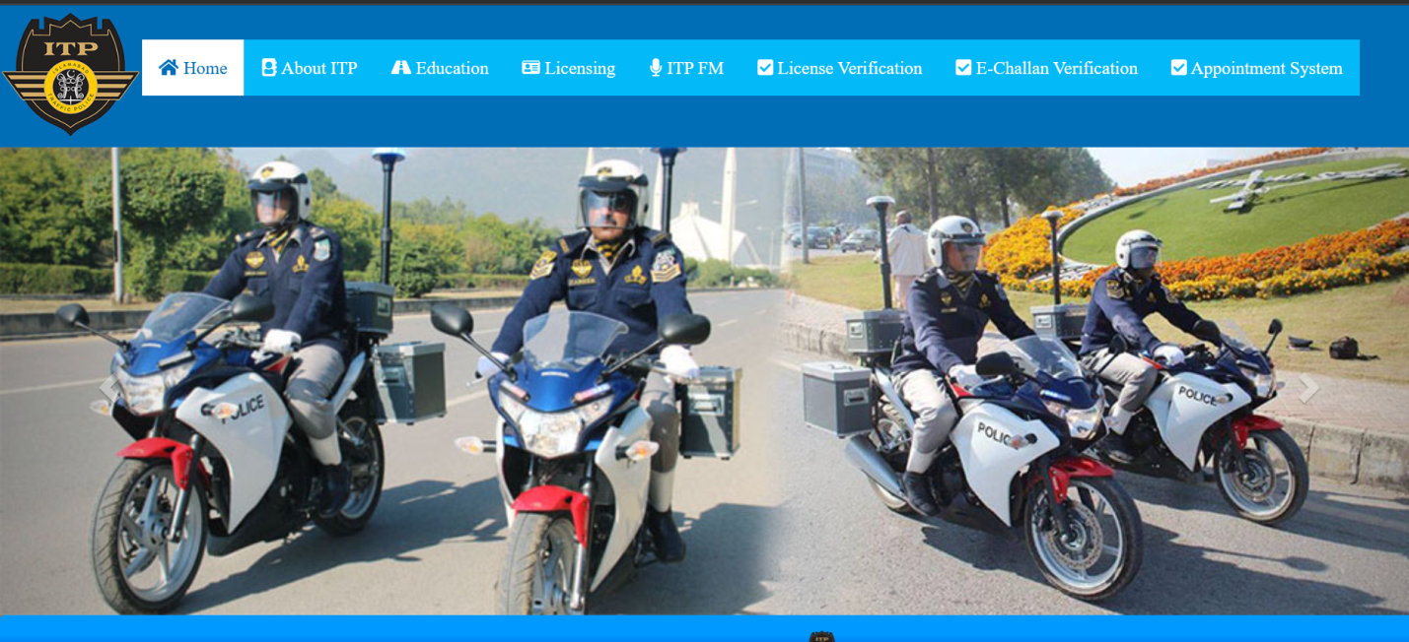

DETAILED GUIDELINE MAPPING

Guideline | Description | Mapping Results (Enhanced Explanation)
Printability | Printing usability | The website does not support print-friendly layouts. Critical pages like challan details include background colors and UI elements that waste ink and reduce clarity.
Mobile | Mobile optimization | The interface is poorly responsive. Users must zoom and scroll excessively, indicating lack of proper viewport scaling and responsive design.
Meta Tags | Metadata usage | Missing or incomplete meta descriptions reduce search engine visibility and user understanding before page load.
Images | Image optimization | Many images lack alt text, violating accessibility standards. Large uncompressed images slow down performance significantly.
Internal Links | Navigation structure | Some internal links are broken or lead to 404 pages, severely impacting usability and trust.
URL Format | URL clarity | URLs include technical parameters instead of clean readable paths, making them hard to remember and share.
Heading | Semantic structure | Headings are inconsistently used. Proper semantic hierarchy (H1 → H2 → H3) is missing.
Page Title | Title clarity | Duplicate titles across pages confuse users and reduce SEO effectiveness.
Freshness | Content updates | Content appears irregularly updated. Important information may become outdated.
Server | Performance/security | Some pages lack proper HTTPS enforcement, leading to browser warnings and reduced user trust.

Conclusion (Task 2):
The Islamabad Traffic Police website suffers from:
- Poor responsiveness
- Weak accessibility
- Broken navigation
These issues significantly reduce usability and user trust.

TASK 3 — UMW WEBSITE ANALYSIS
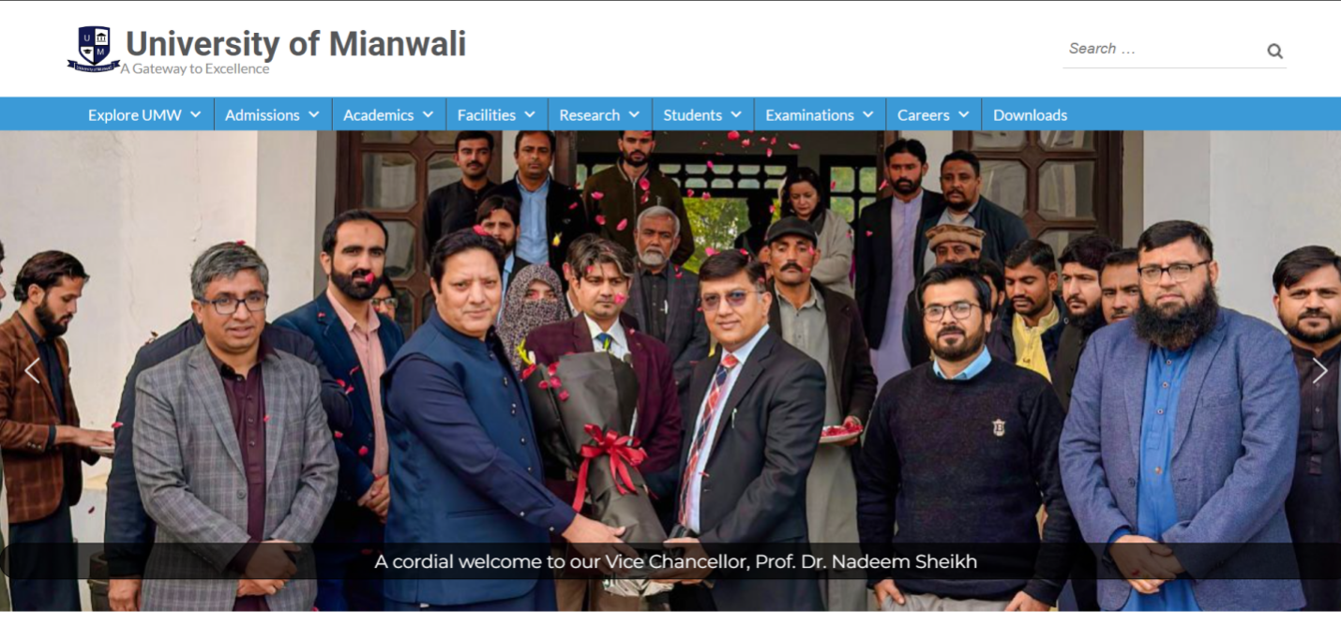

DETAILED GUIDELINE MAPPING

Guideline | Description | Mapping Results (Enhanced Explanation)
Printability | Print support | No optimized print view. Printing academic content results in cluttered and poorly formatted output.
Mobile | Mobile responsiveness | Generally responsive, but large tables (fee structures) break layout on smaller screens.
Meta Tags | Metadata | Basic meta tags exist, but deeper pages lack detailed descriptions.
Images | Image handling | High-quality images improve visuals but are not optimized, affecting load time.
Internal Links | Navigation | Navigation is strong, but some links do not behave consistently (e.g., not opening in new tabs).
URL Format | URL clarity | Clean and hierarchical URLs improve usability and SEO.
Heading | Structure | Proper semantic structure enhances readability and accessibility.
Page Title | Title usage | Titles are dynamic and correctly reflect page content.
Freshness | Updates | Frequently updated content improves credibility and relevance.
Server | Performance | Strong server performance with proper HTTPS implementation and fast loading speeds.

Conclusion (Task 3):
The UMW website demonstrates good usability practices, including:
- Clean structure
- Strong navigation
- Updated content
Minor improvements in responsiveness and optimization can make it excellent.

FINAL OVERALL CONCLUSION
Across all three evaluations:

Weak Systems:
- Islamabad Traffic Police → Poor usability
- AJKU → Average usability

Strong System:
- UMW → Good usability design

Key Learning Outcomes:
This assignment demonstrates that:
- Good UI design requires responsiveness, accessibility, and structure
- Poor design leads to user frustration and inefficiency
- Applying HCI guidelines improves user satisfaction and performance

